 

|  |  |  |
| --- | --- | --- |
| **Module** | **Portfolio** | **Assessment Type** |
| Collaborative Development (5CS024) | 2 | Individual Report |

**Appointment Management System-(Frontend-Developer)**

Student Id : 2228160

Student Name : Ritesh Jung Lama

Section : L5CG4

Group : L5CG4 Group 4

Module Leader : Mr. Biraj Dulal

Lecturer : Mr. Biraj Dulal

Submitted on : 02/04/2023

**Acknowledgements**

I have been able to successfully develop the Appointment Management System, thanks to the constant guidance and support of our instructor, Mr. Aadhrsha Khadka. Their valuable inputs and direction have been crucial in making this project a reality, and I express my heartfelt gratitude to them.

While developing this system, I have learned numerous concepts, such as effective time management, communication, and coordination with team members. Additionally, I have gained knowledge on the importance of user experience and the significance of creating a user-friendly interface that is easy to navigate and understand.

I would also like to thank my team members who have played a crucial role in the success of this project. Their support, trust, and commitment to the project have been essential in making this project a success.

Overall, I am proud of the Appointment Management System we have developed, and I am confident that it will be of great use to its intended users.

Table of Contents

Self-appraisal form 5

Personal objectives – performance measurement 5

Collaboration Document 7

Evidence of good collaboration 7

Continuing Personal Development (CPD) 8

**Issue tracking** 9

Appendix A 10

Implementing functional requirement 10

Login Feature 10

Code of Login 11

Signup Feature 12

Patient Dashboard 14

Patient Homepage 14

Patient Hompage Code 15

Search Doctor Page 16

View Doctor Page 18

View Doctor Code 19

Book Doctor Page 21

Book Doctor code 22

Doctor Dashboard 23

Doctor Request Page 23

Code of Doctor Request Page 24

Doctor Homepage 26

Code of Doctor Homepage 27

Appointment Details Page 28

Implementing functional requirement 33

Codes and its explanation 33

Use of Version control (Screenshots of logs) 35

Appendix 2 38

Evidences of Good communication and file sharing 38

Evidence of Continuing Personal Development (CPD) 40

Evidences of Issue tracking 40

Figure 1Login page 11

Figure 2Login code 12

Figure 3Signup page 13

Figure 4Signup page 16

Figure 5Patient Homepage 17

Figure 6Patient Homepage Code 18

Figure 7Search Doctor Page 19

Figure 8Search Doctor Page Code 20

Figure 9View Doctor Page 21

Figure 10View Doctor Code 24

Figure 11Book Doctor page 24

Figure 12Book doctor code 25

Figure 13Doctor request page 26

Figure 14code of doctor request page 27

Figure 15Doctor homepage 28

Figure 16Code of Doctor homepage 29

Figure 17Appointment details page 30

Figure 18Code of appointment datails 32

Figure 19 profile personal info page 32

Figure 20 profile page 33

Figure 21 Profile page code 35

Figure 22 profile page 36

Figure 23 Total commit screenshot 37

Figure 24 github commit 37

Figure 25 BaseCamp messages screenshot 1 38

Figure 26BaseCamp messages screenshot 2 38

Figure 27 email messages screenshot 1 39

Figure 28 email messages screenshot 2 39

Figure 29 Issue tracking Screenshot 41

# Self-appraisal form

|  |  |  |  |
| --- | --- | --- | --- |
| Student number | 2228160 | Name | [Ritesh Jung Lama](mailto:np03cs4s220363@heraldcollege.edu.np) |
| Project | Appointment Management System | Date | 01/04/2023 |
| Role | Developer | Team | L5CG4 (group 5) |
| Sprint (1 or 2) | 2 |  |  |

# Personal objectives – performance measurement

|  |  |  |  |
| --- | --- | --- | --- |
| **Objectives** | **Evidence provided** | **Evaluation**  *Student / tutor* | |
| Implementing  Functional  requirement | After the completion of sprint 1, our team came up with the plan to make start making the dashboard for doctors. Since 70% of our work was completed on Sprint 1 we have enough time left to prepare for sprint 2. So we added the doctor dashboard page when the doctor logins into the system.  **Appendix A** | 9 |  |
| *Tutor feedback:* | | | |
| Bug fixing | This part of the process was easy. Our team had made a process for this part. The process was whenever I make a huge change in our mobile app, I build the apk file and send it to the BA of our team then he tests the application and find bugs and make a bug report on it which I solve later.  **Appendix B** | 9 |  |

# Collaboration Document

## Evidence of good collaboration

|  |
| --- |
| I feel lucky to have such a good team member on my team. For our collaboration we used Basecamp for the communication and incase of urgent message we used email for the communication. For the development part we used version control system Github. In Github our developers push the code regularly and the PM and Ba testes the code and created Issues on Github. This hierarchy helped us for good collaboration. |

## Continuing Personal Development (CPD)

|  |
| --- |
| In my role as a Flutter developer, I did a haptic amount of research to figure out how to build mobile apps and make it in the best practice ever. I even checked out for time complexity and space complexity of the code and did my best to reduce it. I did a lot of research on the internet for content, documentation and watched YouTube videos to learn the build . I also spent time looking into how to handle state in Flutter, which can be a bit tricky sometimes. Whenever I got stuck and ran into errors, I went straight to Stack Overflow for answers. I even used this AI Chat to help me out and fix those problems. |

## **Issue tracking**

|  |
| --- |
| Since our code was uploaded on GitHub. We used the feature of Github issues for our issue tracking. Our business analyst constantly checked for the changes in github and then created the issue If any issues were found on the code. Later on, the development team fixes the issue and then closes the issue in github. This process continued until the bug was fixed |

# Appendix A

# **Implementing functional requirement**

## Login Feature

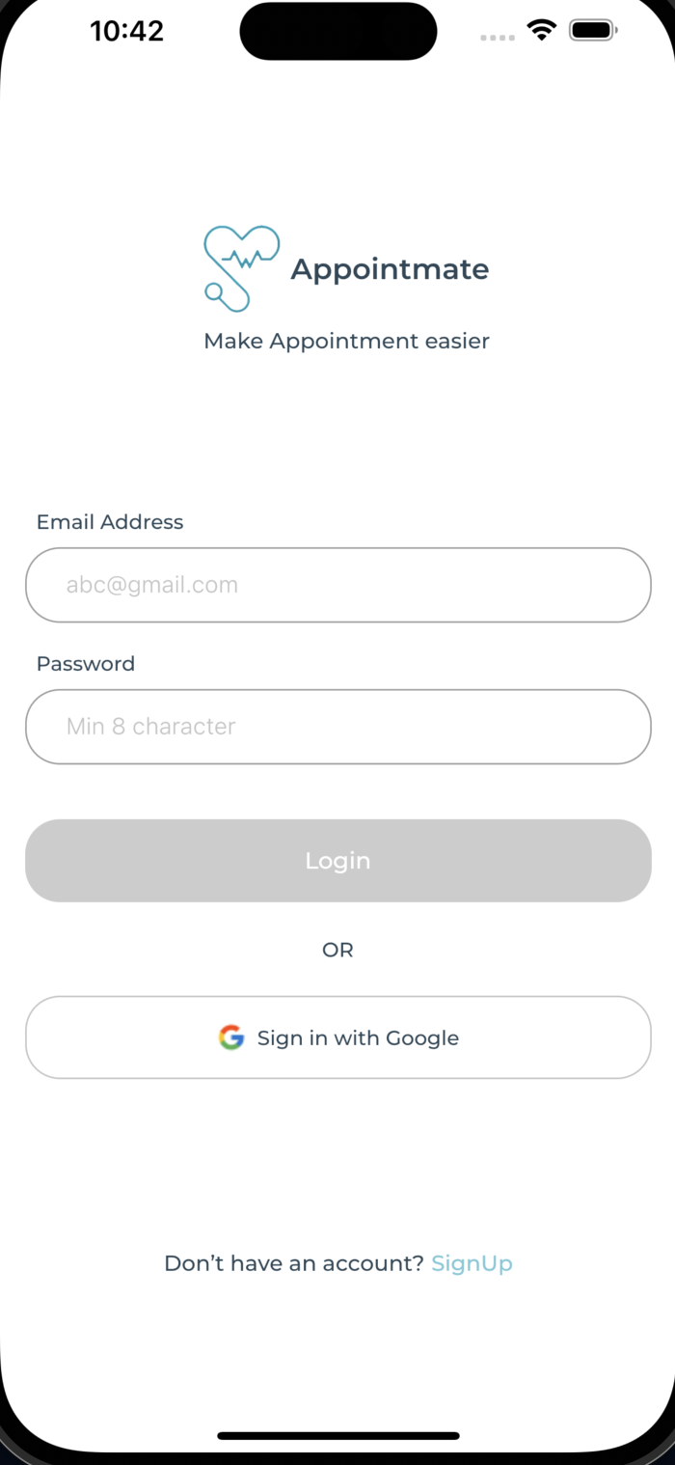

Figure 1Login page

## Code of Login

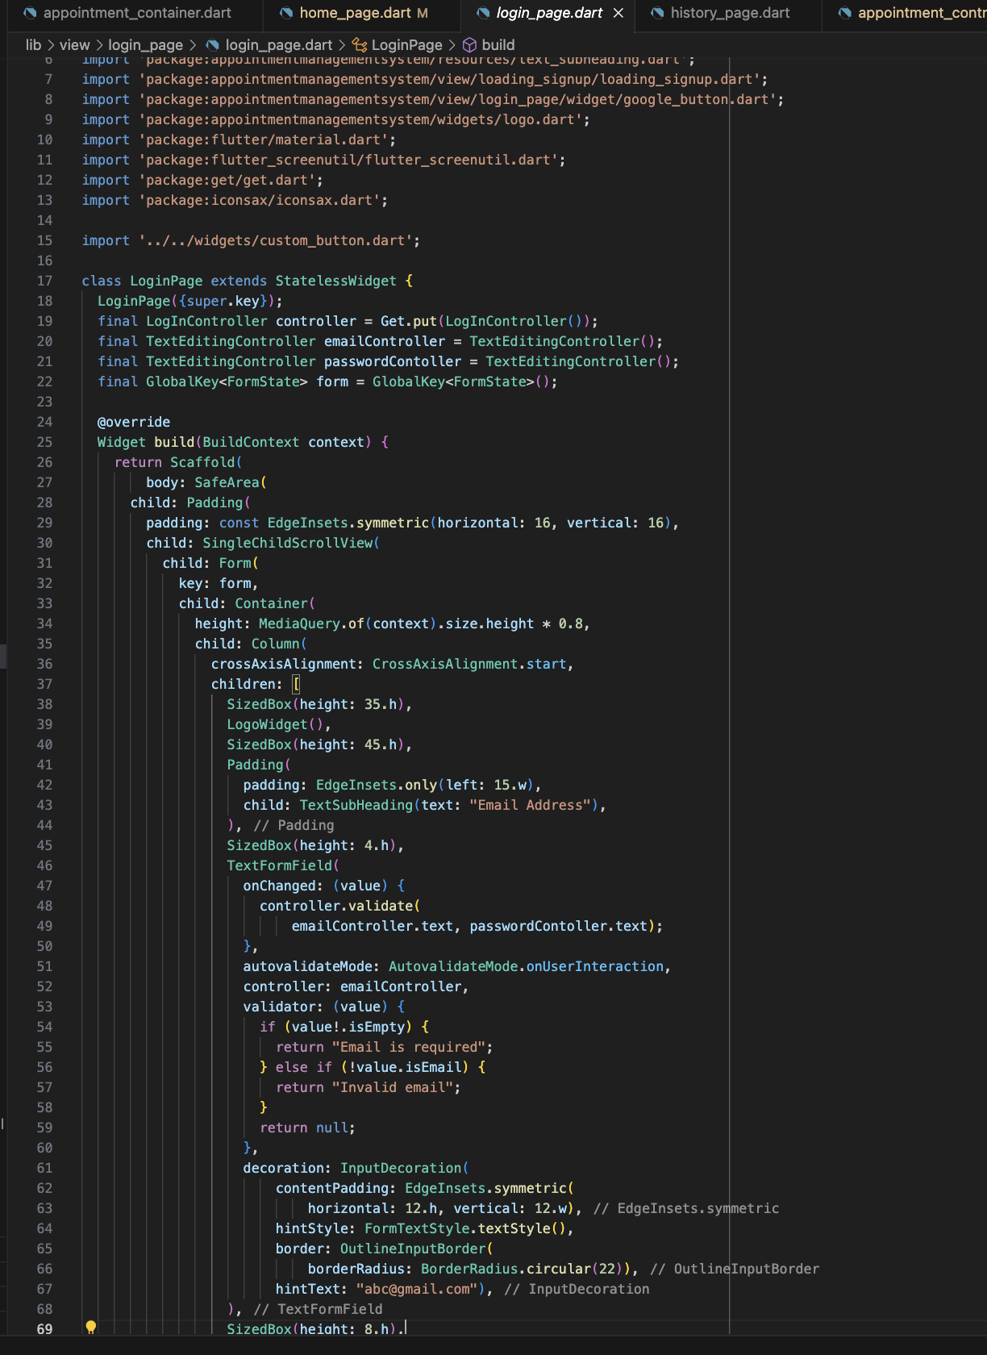

Figure 2Login code

## Signup Feature

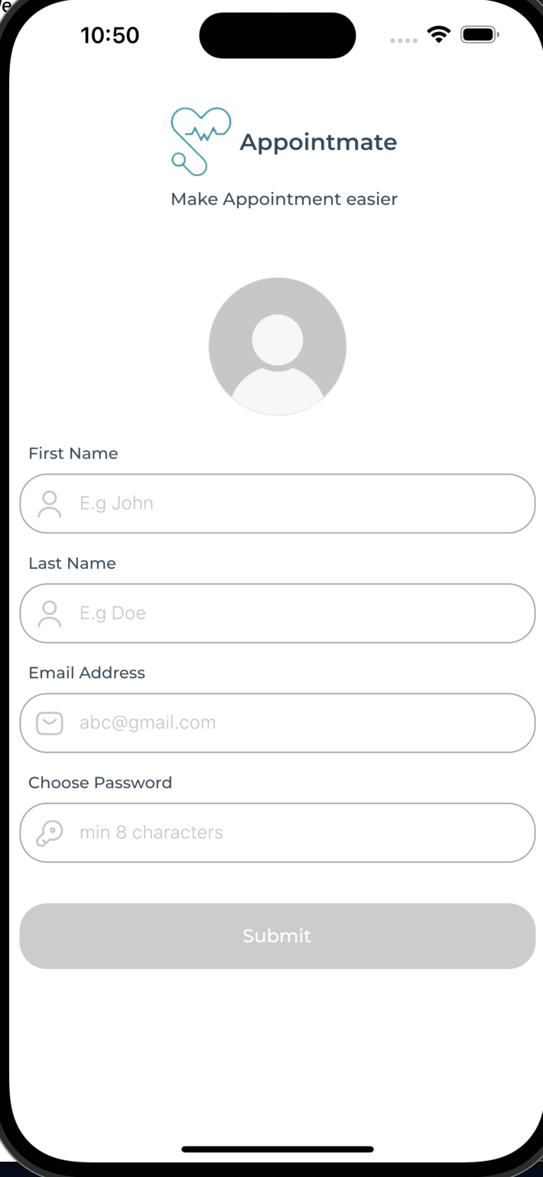

Figure 3Signup page

Code of Signup

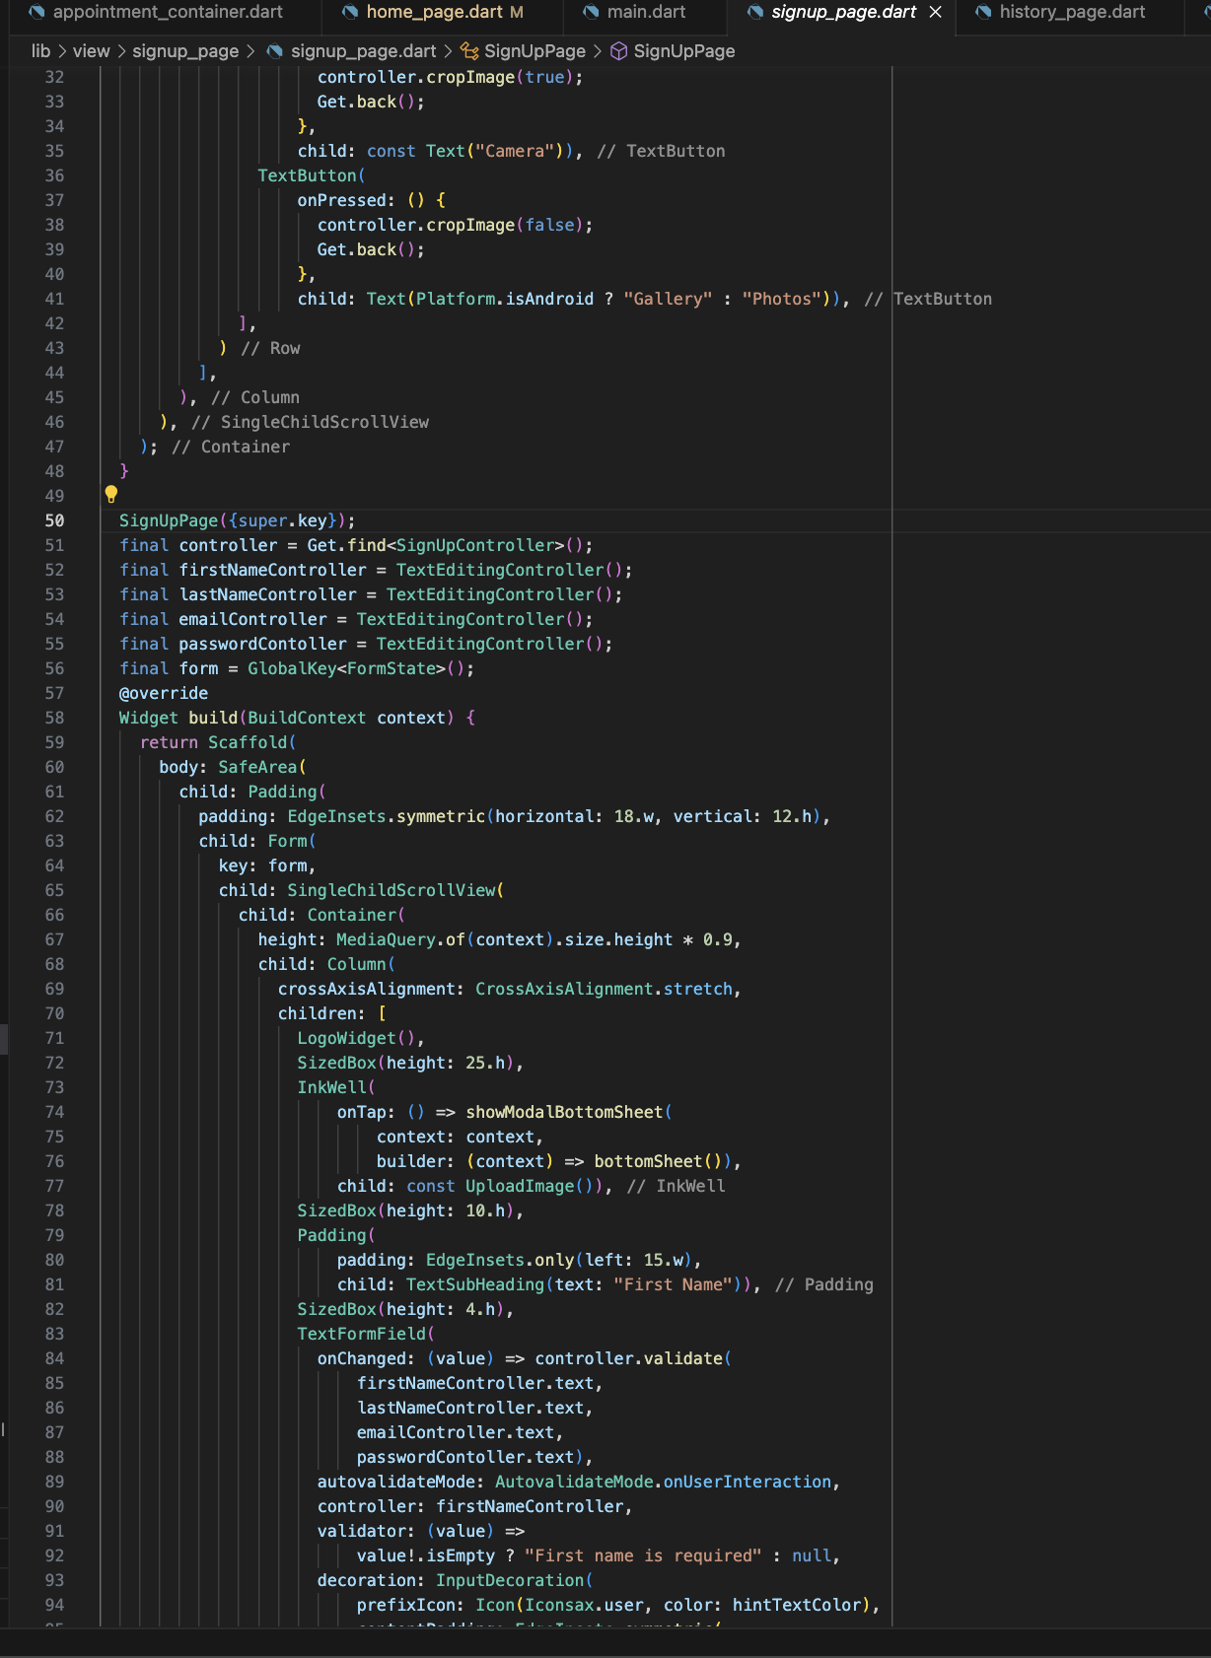

Figure 4Signup page

# Patient Dashboard

## Patient Homepage

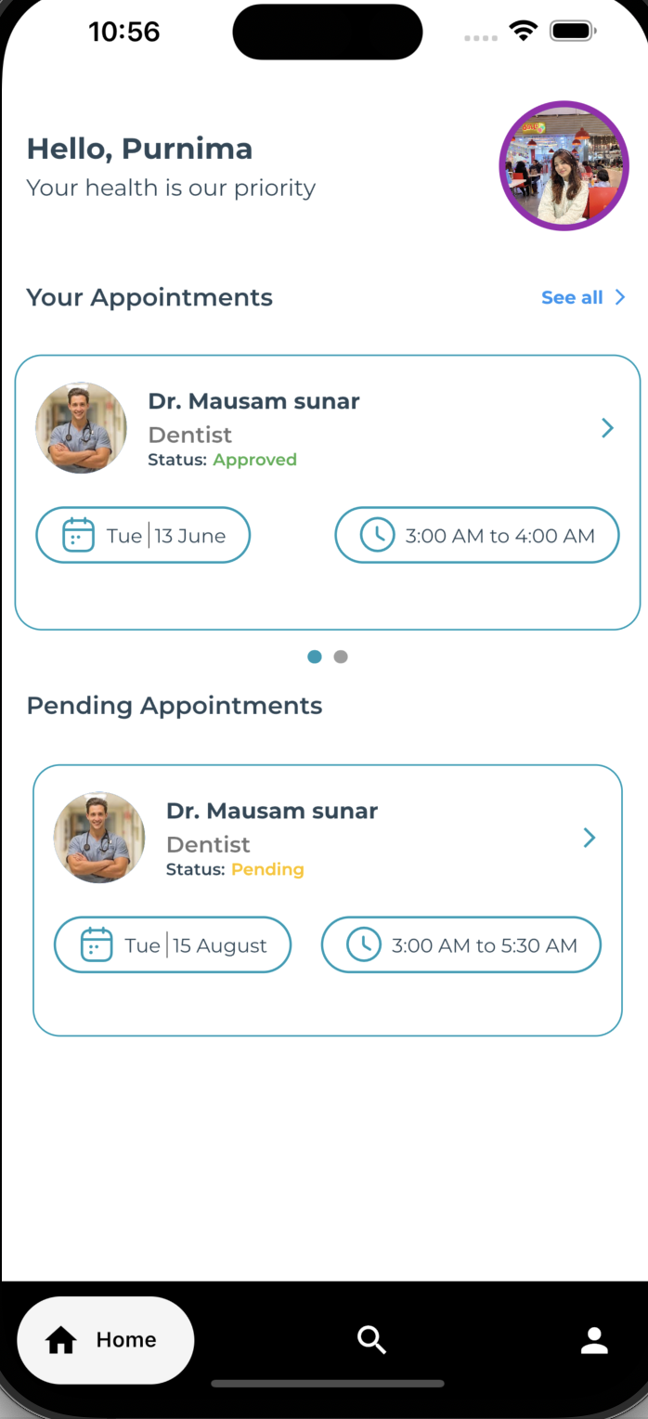

Figure 5Patient Homepage

### Patient Homepage Code

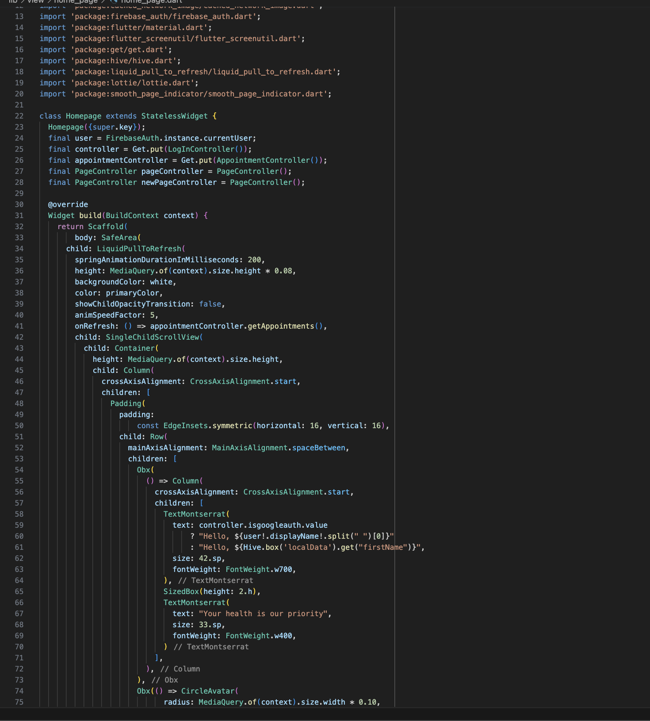

Figure 6Patient Homepage Code

## Search Doctor Page

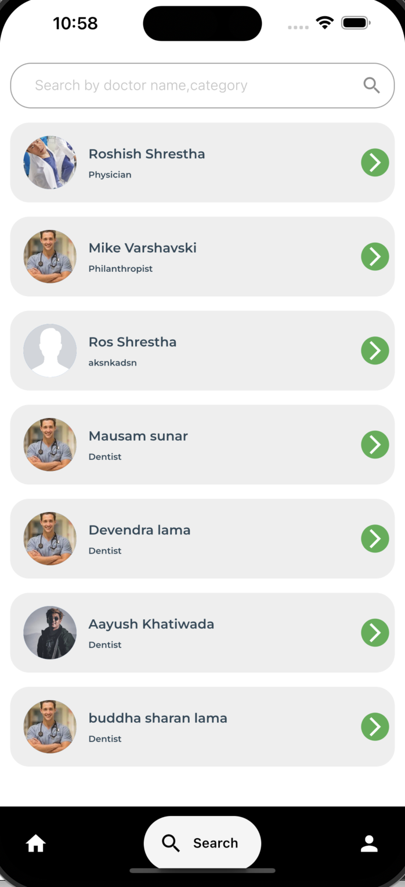

Figure 7Search Doctor Page

Search Doctor Page Code

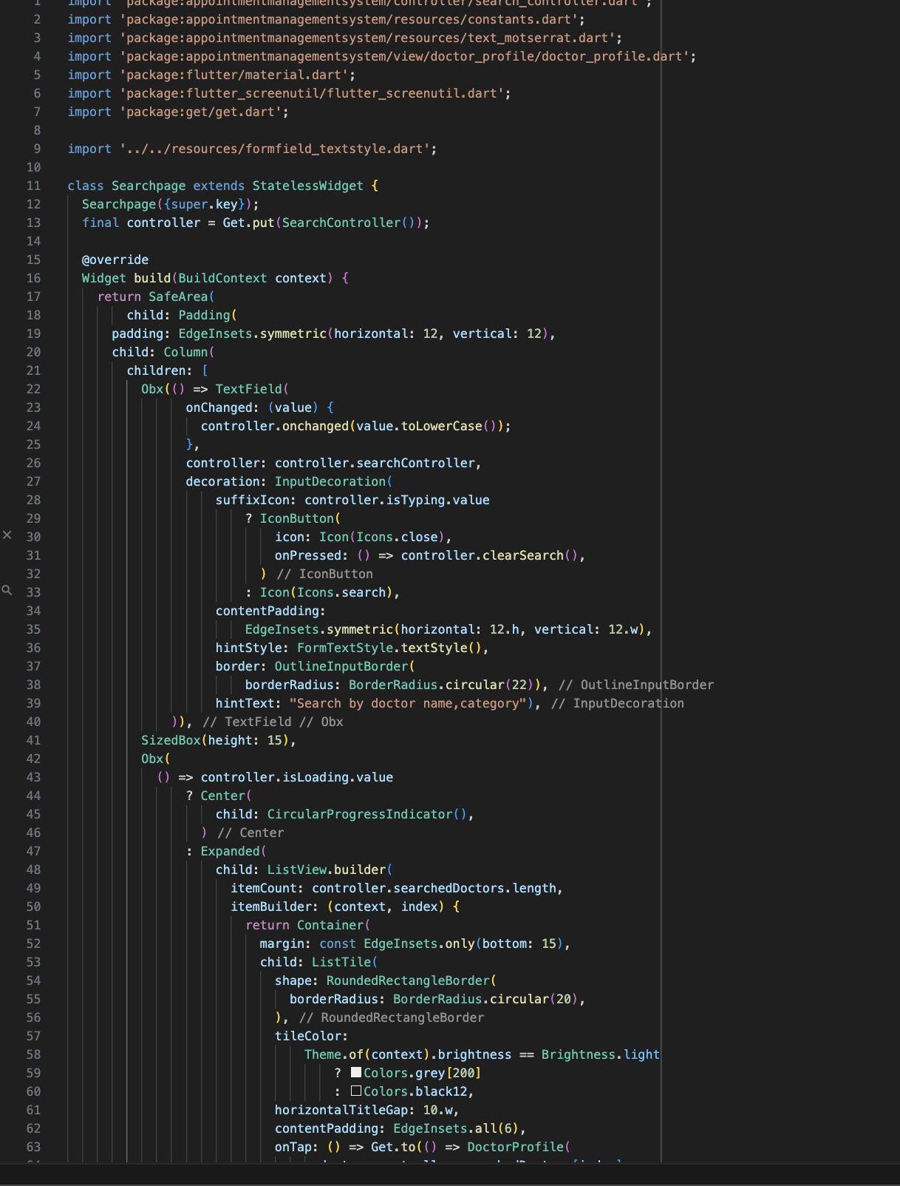

Figure 8Search Doctor Page Code

## View Doctor Page

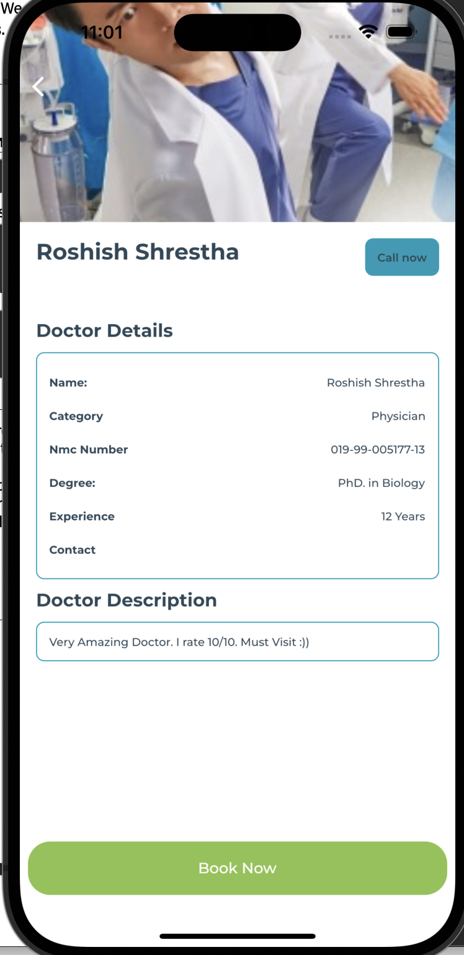

Figure 9View Doctor Page

### View Doctor Code

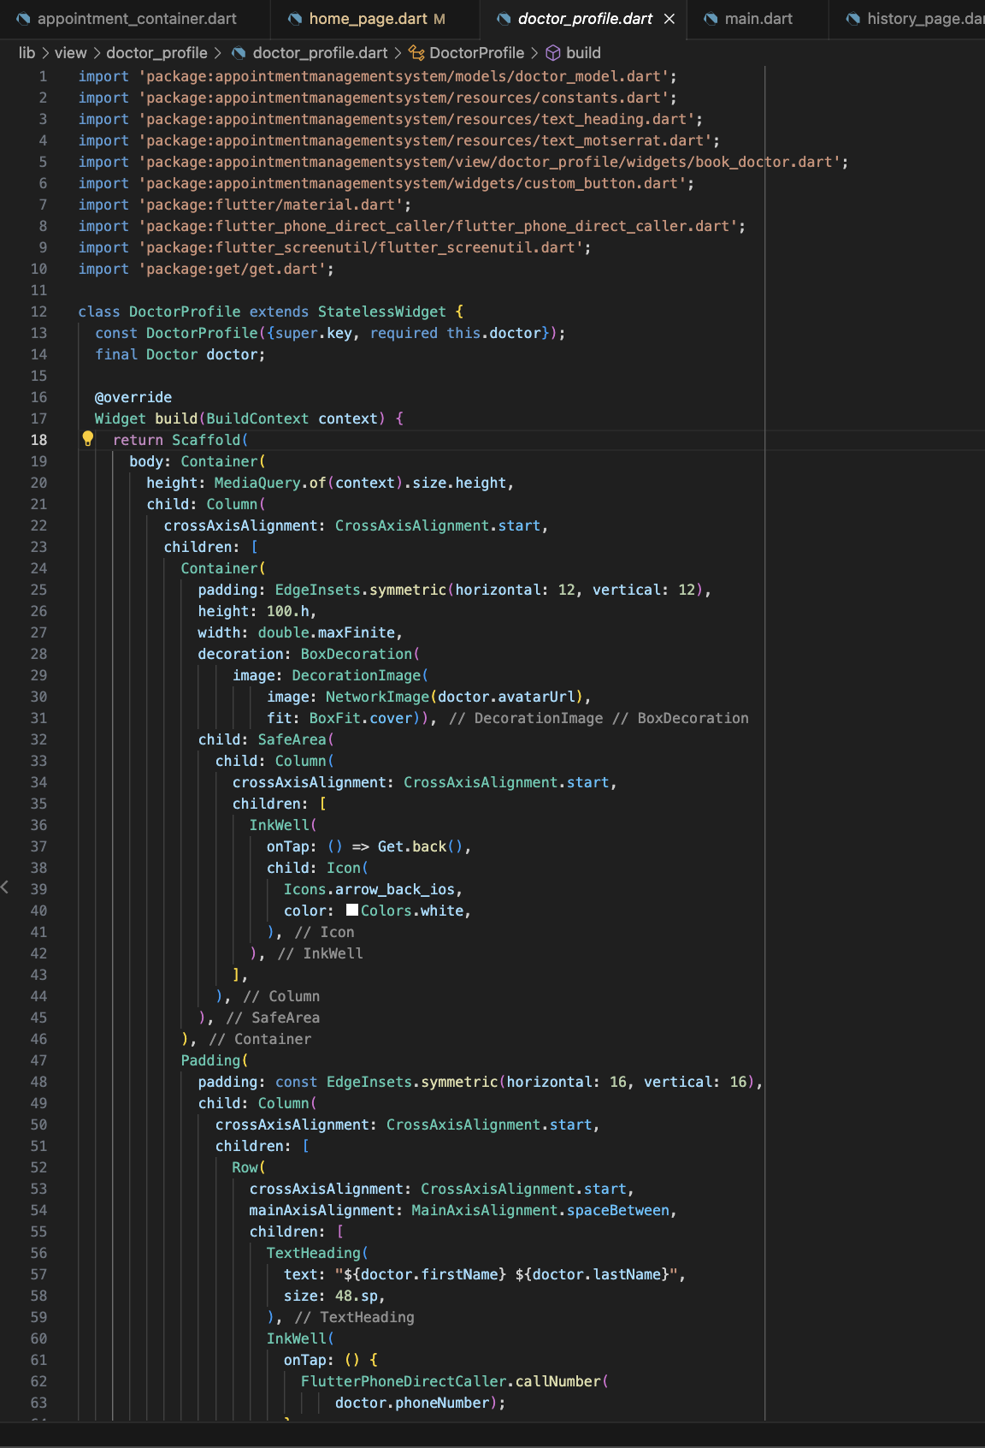

Figure 10View Doctor Code

# Book Doctor Page

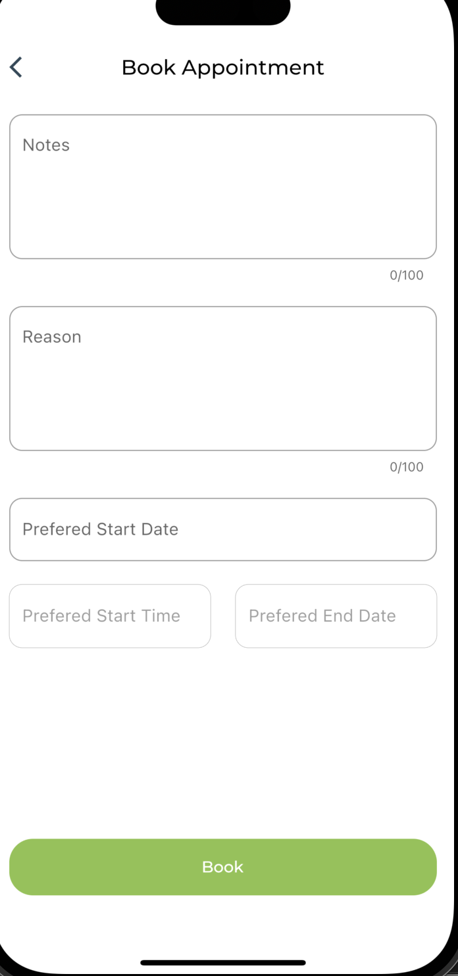

Figure 11Book Doctor page

### Book Doctor code

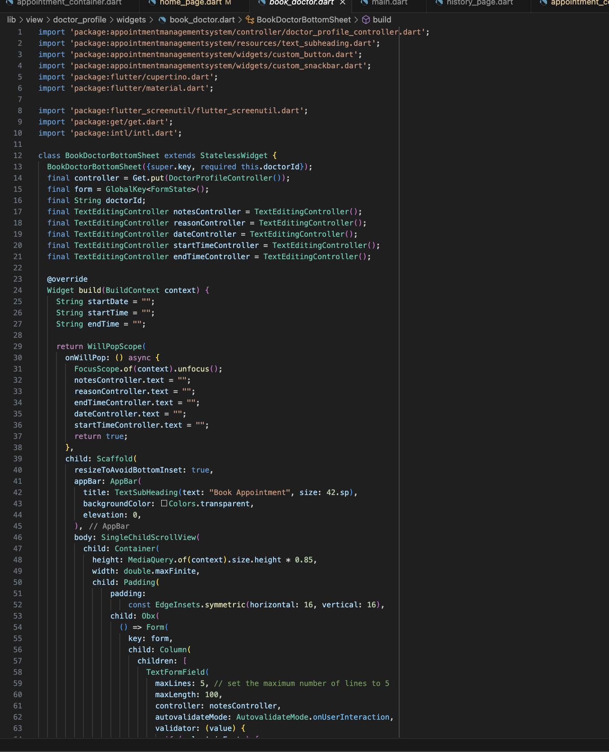

Figure 12Book doctor code

## Doctor Dashboard

## Doctor Request Page

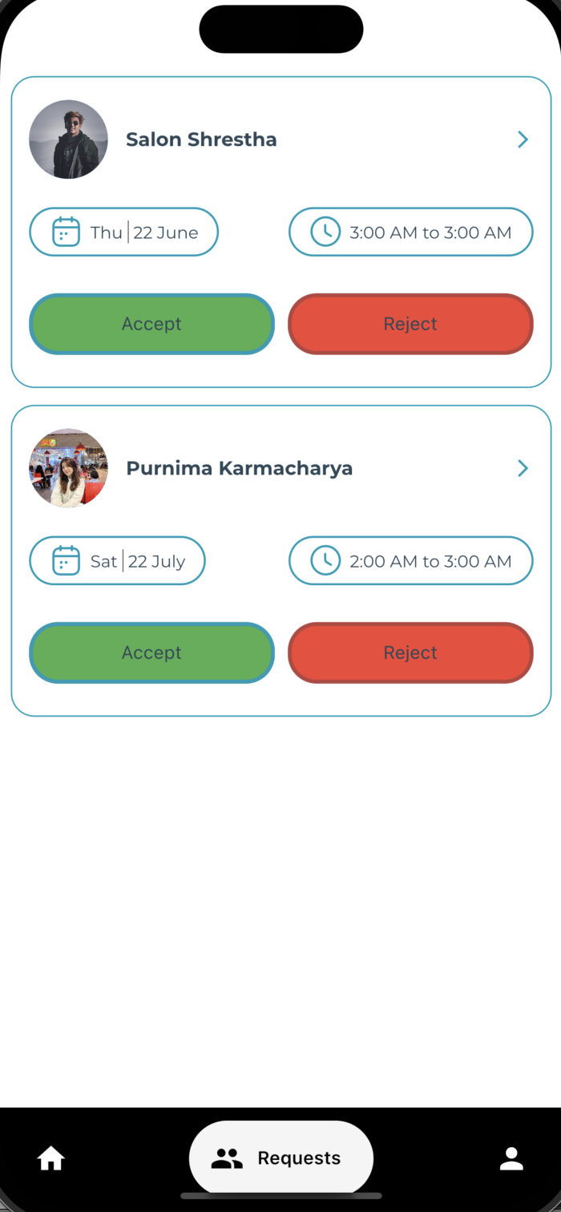

Figure 13Doctor request page

## Code of Doctor Request Page

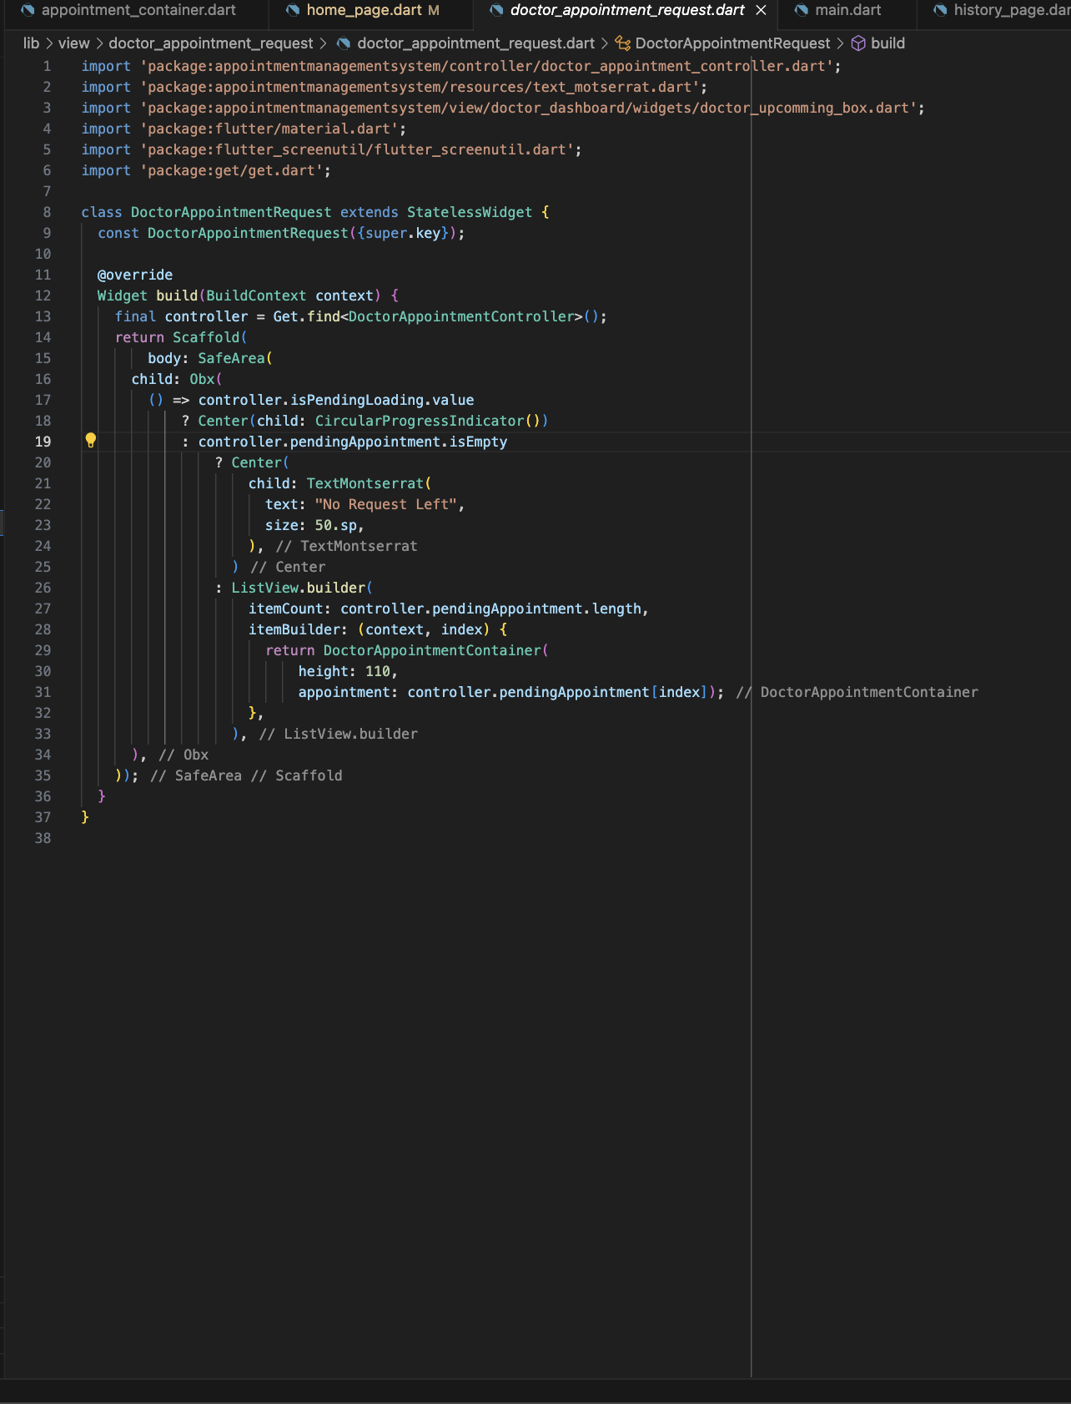

Figure 14code of doctor request page

## Doctor Homepage

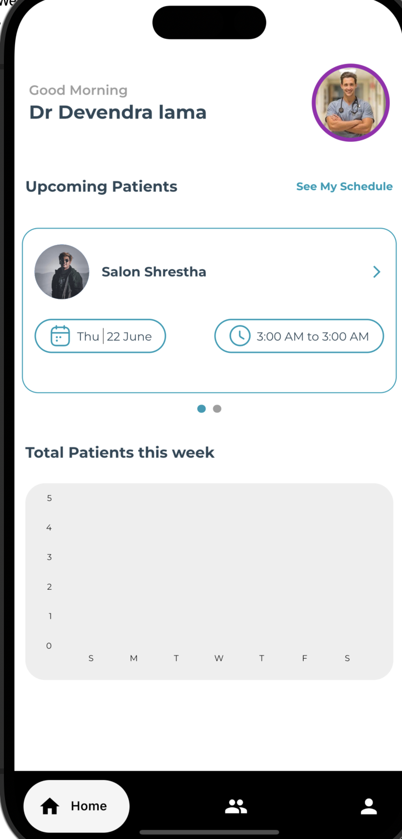

Figure 15Doctor homepage

### Code of Doctor Homepage

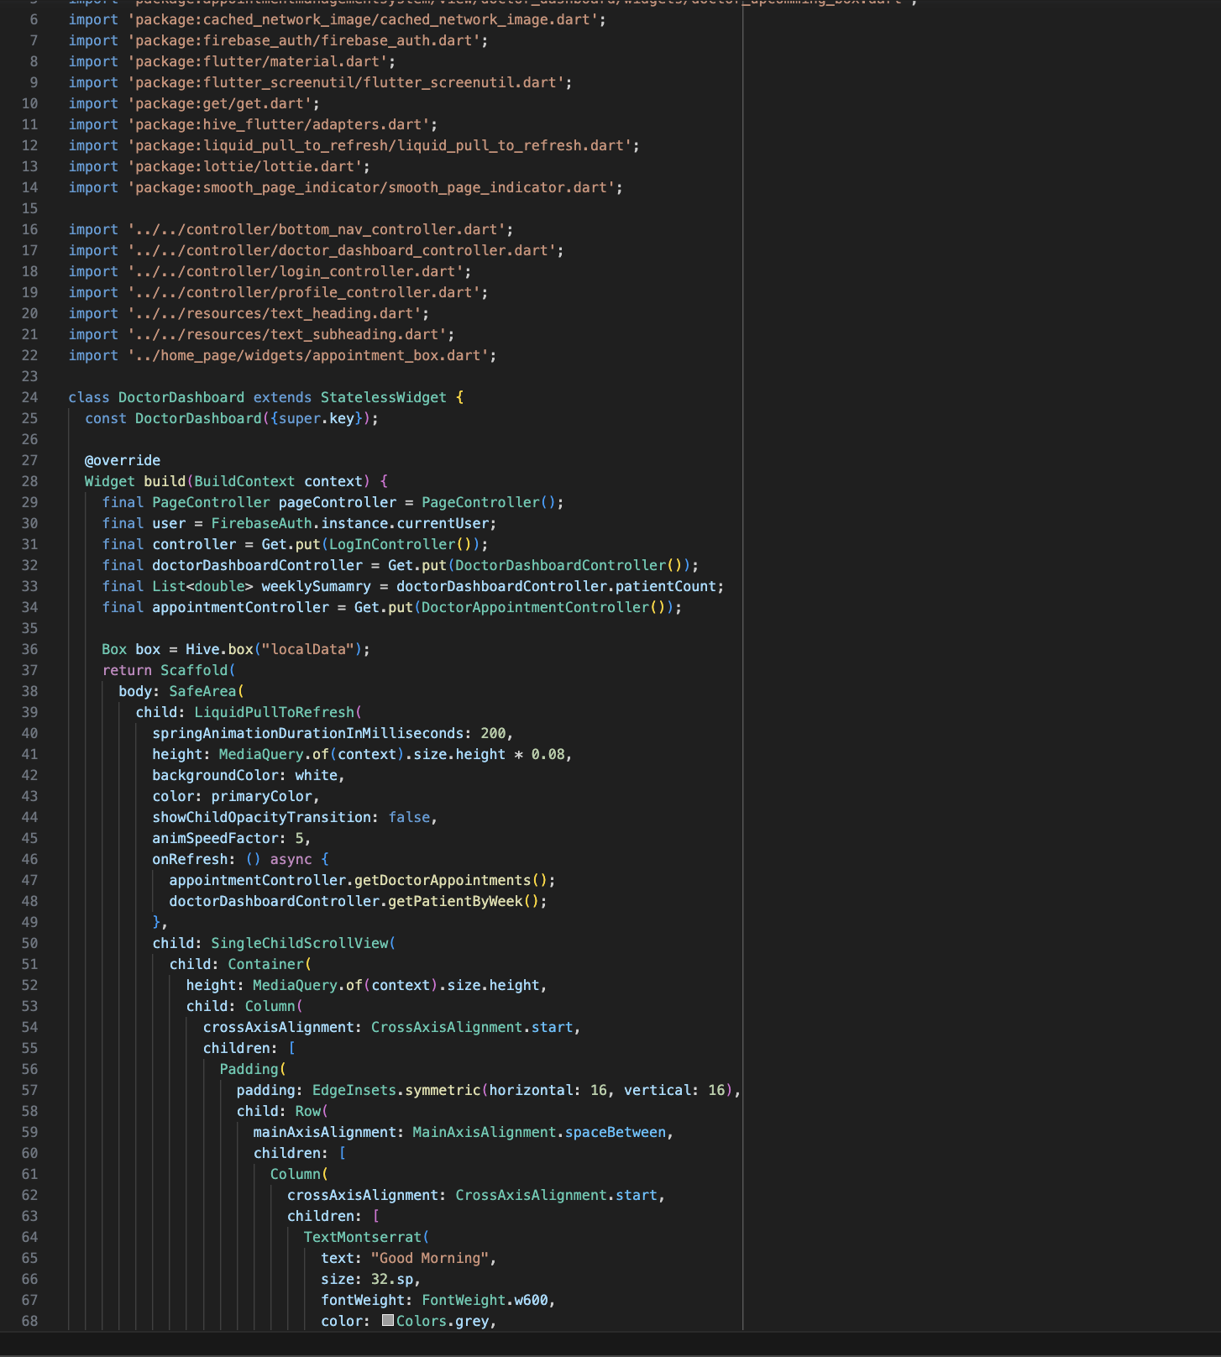

Figure 16Code of Doctor homepage

# Appointment Details Page

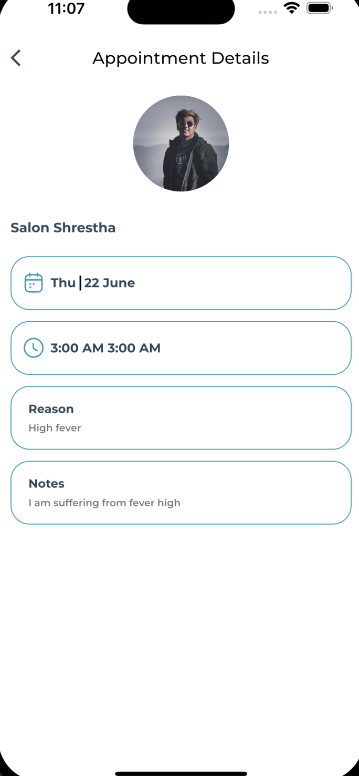

Figure 17Appointment details page

Code of Appointment Details

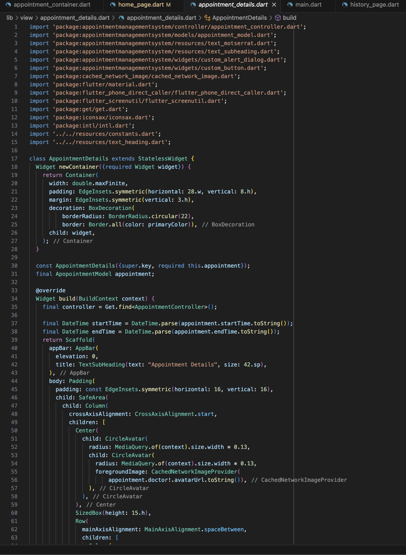

Figure 18Code of appointment datails

Profile Page

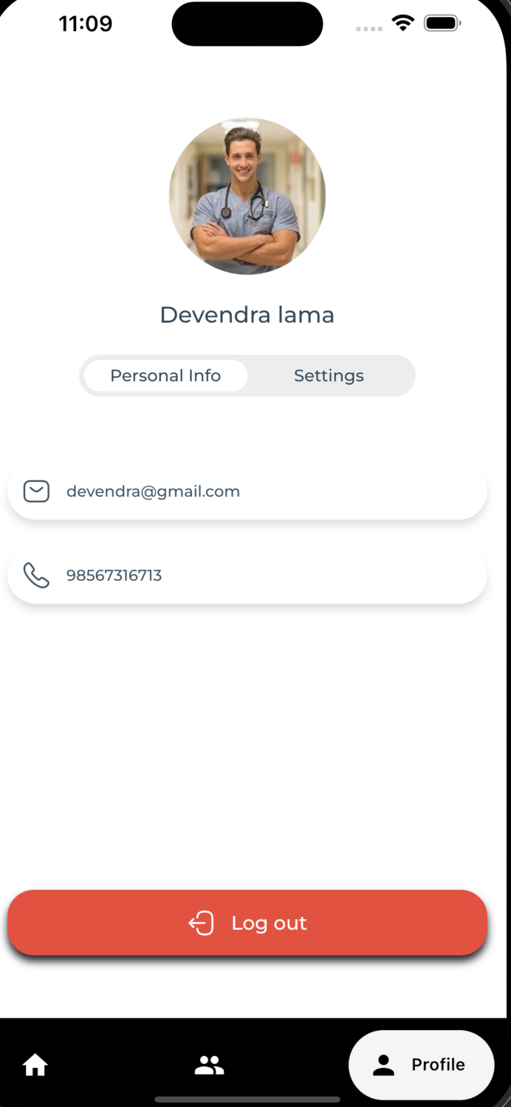

Figure 19 profile personal info page

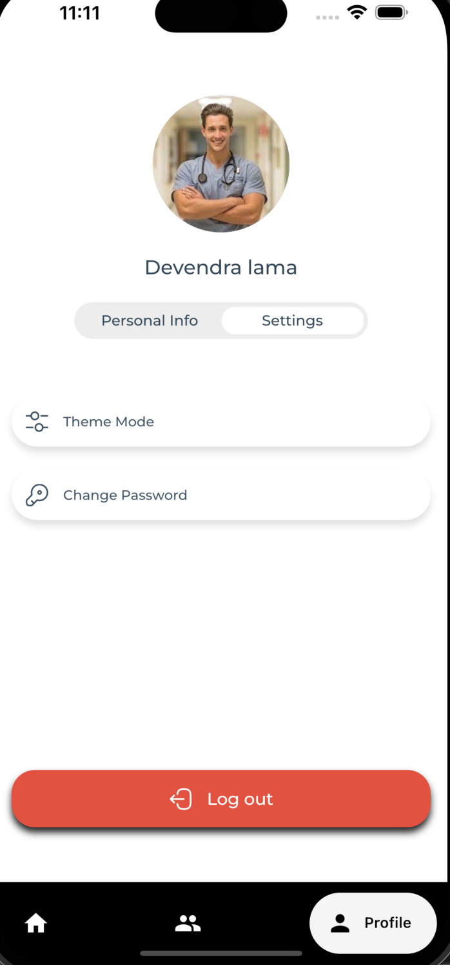

Figure 20 profile page

Code of Profile Page

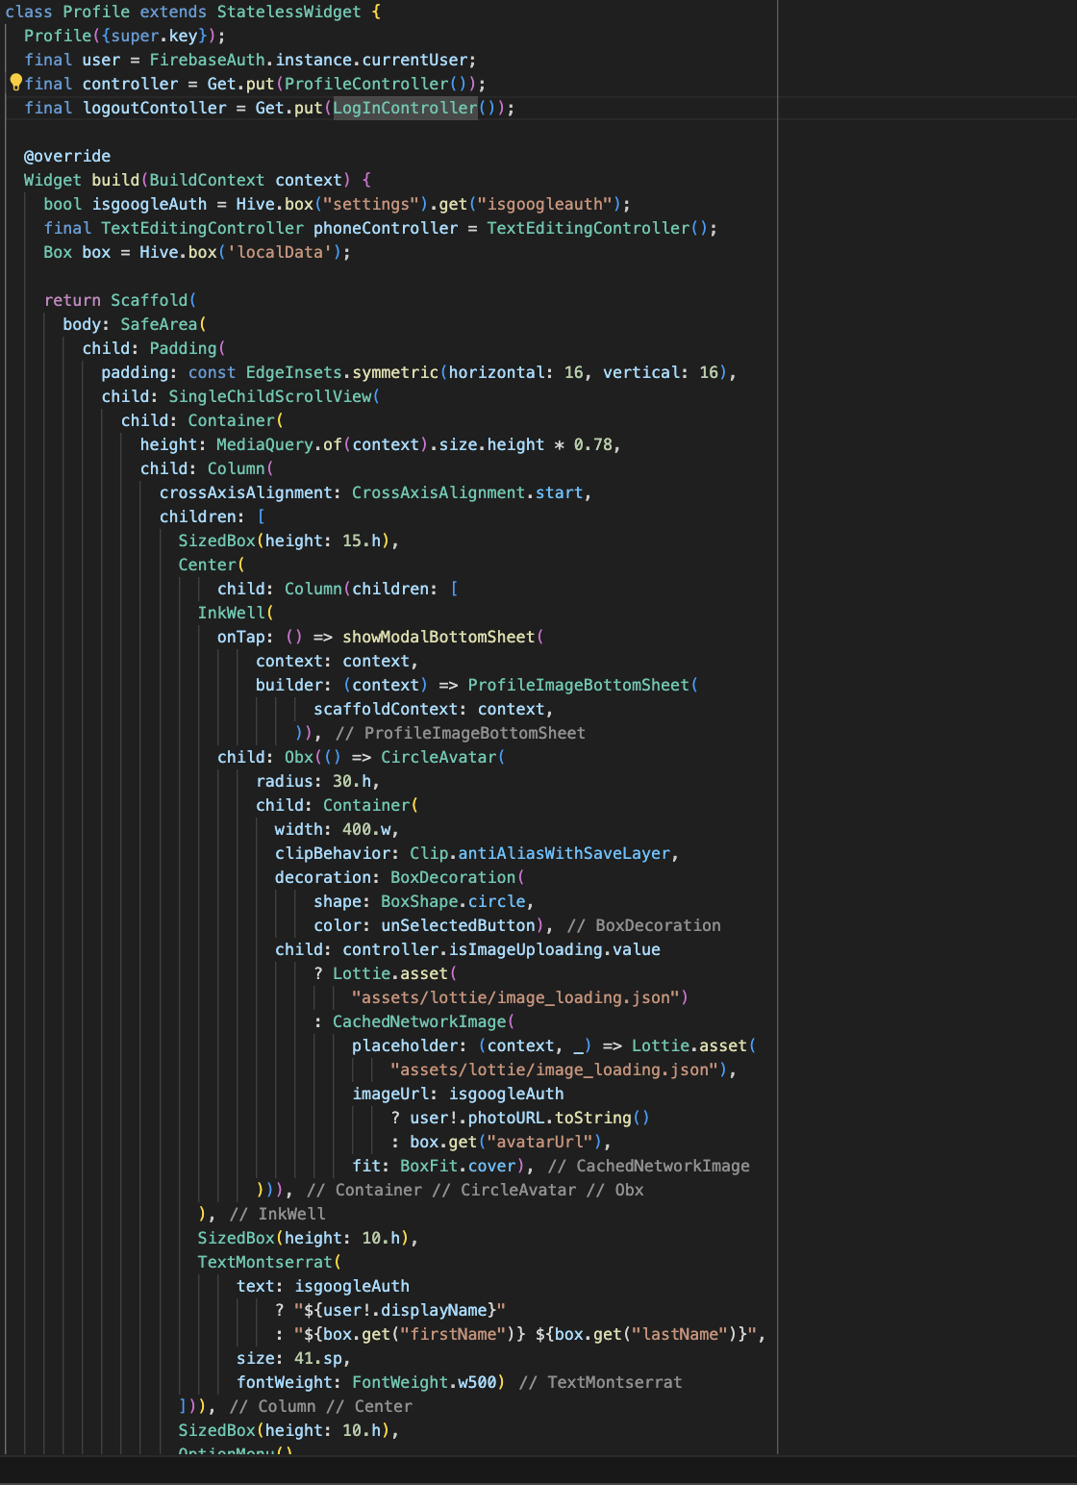

Figure 21 Profile page code

# Appendix B

## White Box testing

|  |  |
| --- | --- |
| Test Name | Test1 |
| Bug | Image Error in Profile Page |
| Tester / Reporter | Roshish Shrestha |
| Date | 29th March |
| Solved Photo | Figure 22 profile page |
| Device | iPhone 14 pro max |
| Severity | High |
| Responsibility | Ritesh Jung Lama |
| Priority | High |

* Detail  
  The image of profile didn’t show
* Action to reproduce.
  1. Open the applicaition
  2. Login if you are not loggedin
  3. Navigate through the profile from bottom nav bar.
* Expected Result

Show the picture of the user

# Use of Version control (Screenshots of logs)



Figure 23 Total commit screenshot

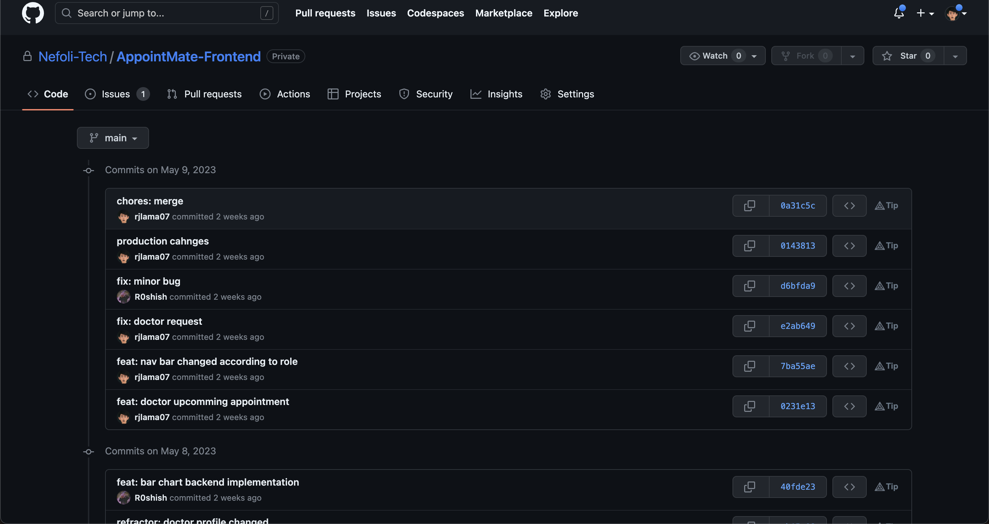

Figure 24 github commit

As a member of our awesome development team, I've been actively contributing to our projects by making a bunch of commits to our GitHub repository. And you know what? I make sure to follow the right format for those commit messages, keeping things organized and collaborative.

I've been on a roll, making a total of 113 commits so far. Each commit represents a different change or improvement we've made to our codebase. From fixing pesky bugs to adding cool new features, I've been working hard to make our applications better for the folks using them.

But it's not just about me and my commits. I've also taken the time to review and check out the code changes made by my fellow team members. It's important to give feedback and suggestions, so we can all work together to make our codebase more solid and efficient.

Overall, my dedication to clear and organized commits shows how much I care about our team's work. Let's keep rocking those projects!

# Appendix 2

## Evidences of Good communication and file sharing

Figure 25 BaseCamp messages screenshot 1

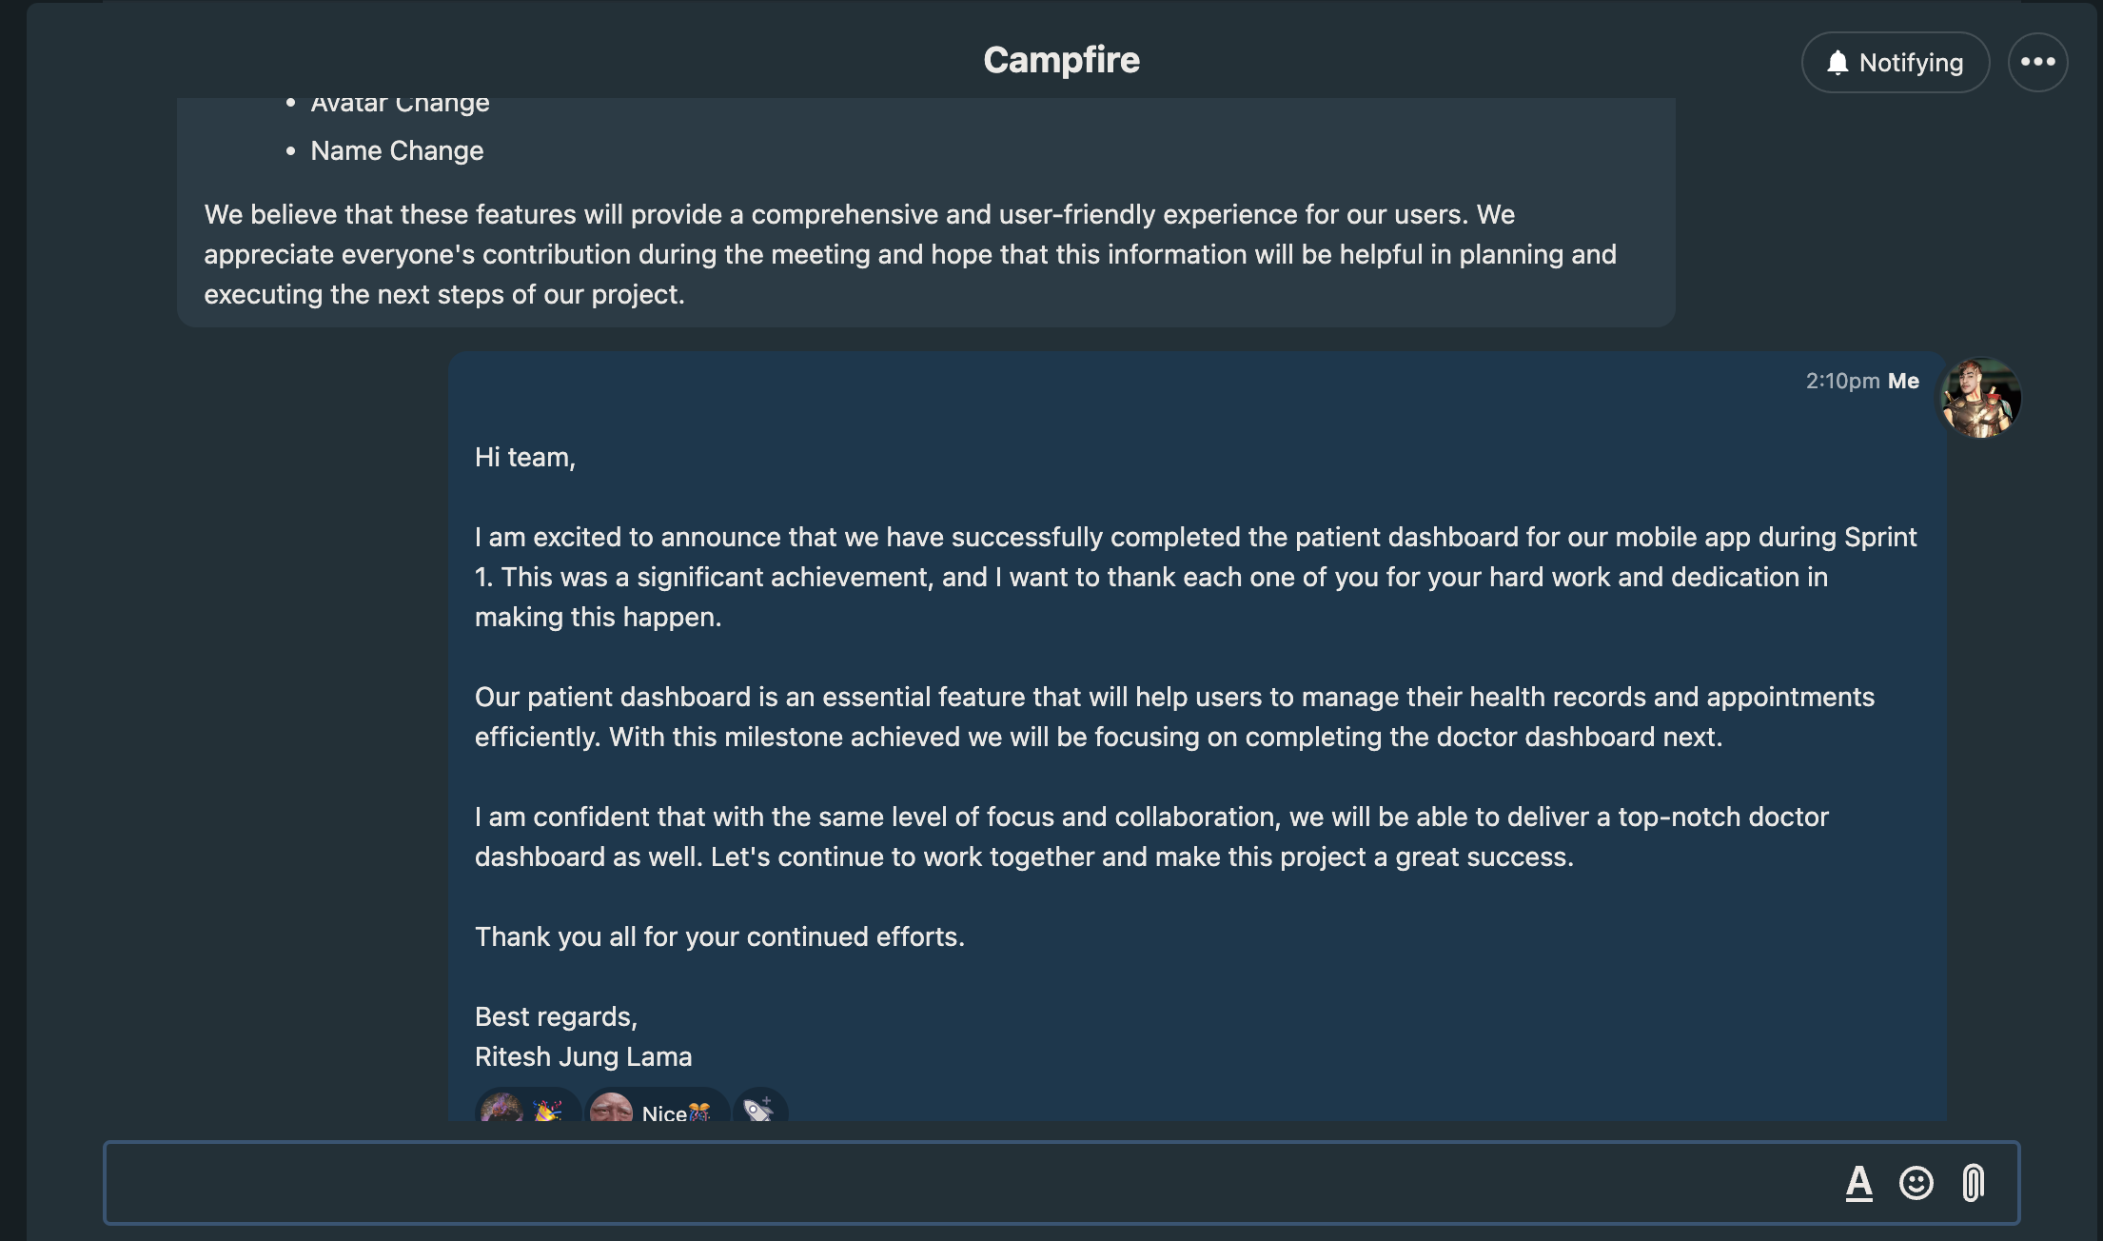

Figure 26BaseCamp messages screenshot 2

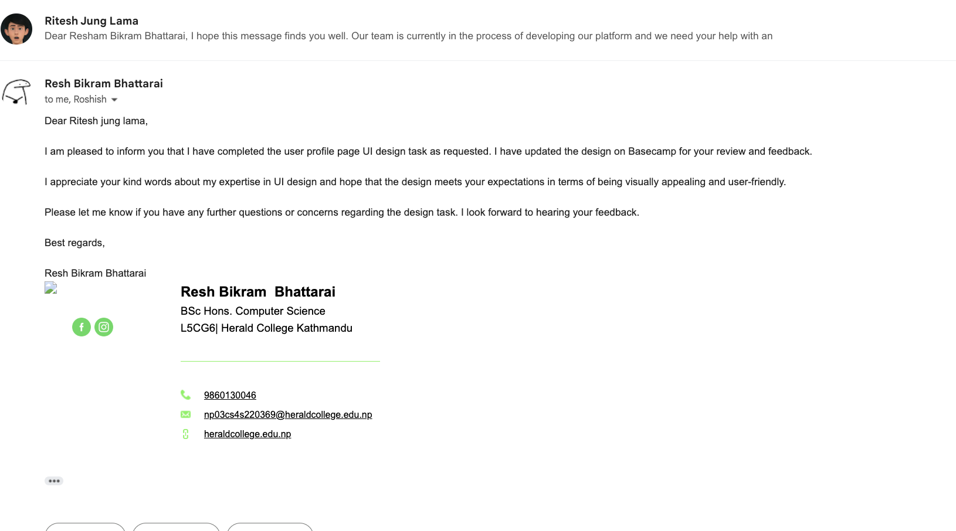

Figure 27 email messages screenshot 1

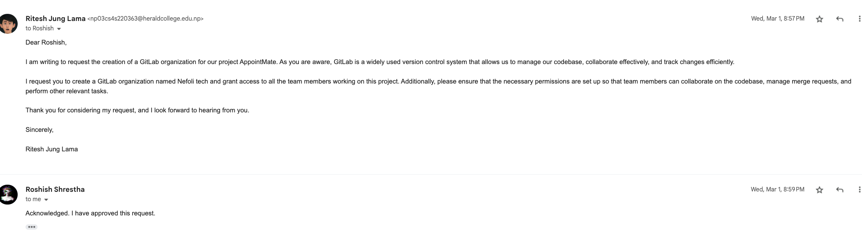

Figure 28 email messages screenshot 2

Here are the screenshot of good communication

## Evidence of Continuing Personal Development (CPD)

Being a dedicated Flutter developer, I truly understand the importance of thorough research when it comes to delivering exceptional applications. That's why I've invested a significant amount of my time into gaining a deep understanding of the mobile application development process. I've scoured the internet, hunting for relevant documentation, and I've devoured educational videos on YouTube to stay on top of the game. I've made it a habit to explore industry best practices to ensure that I'm delivering top-notch work.

In addition, I've made it a point to keep myself updated with the latest advancements in state management within Flutter. I follow influential developers in the community on social media and actively participate in virtual meetups and webinars. This way, I stay in the loop about the newest trends and techniques that emerge in this ever-evolving field.

Now, despite my meticulous approach, there have been instances where I've come across complex challenges that needed some expert guidance. That's when I turned to reliable online resources like Stack Overflow and Quora. These platforms have proven to be gold mines of invaluable insights and advice from experienced developers who have faced similar hurdles.

Moreover, I've also recognized the benefits of leveraging AI chatbots to swiftly troubleshoot and resolve issues. These AI-powered assistants have been a game-changer in terms of maintaining efficiency and meeting project deadlines. By using them, I've been able to overcome obstacles effectively and ensure a smooth development process.

All in all, my commitment to thorough research, continuous learning, and leveraging reliable resources reflects my dedication to delivering exceptional Flutter applications. I'm always striving to enhance my skills and stay at the forefront of this exciting field.

## Evidences of Issue tracking

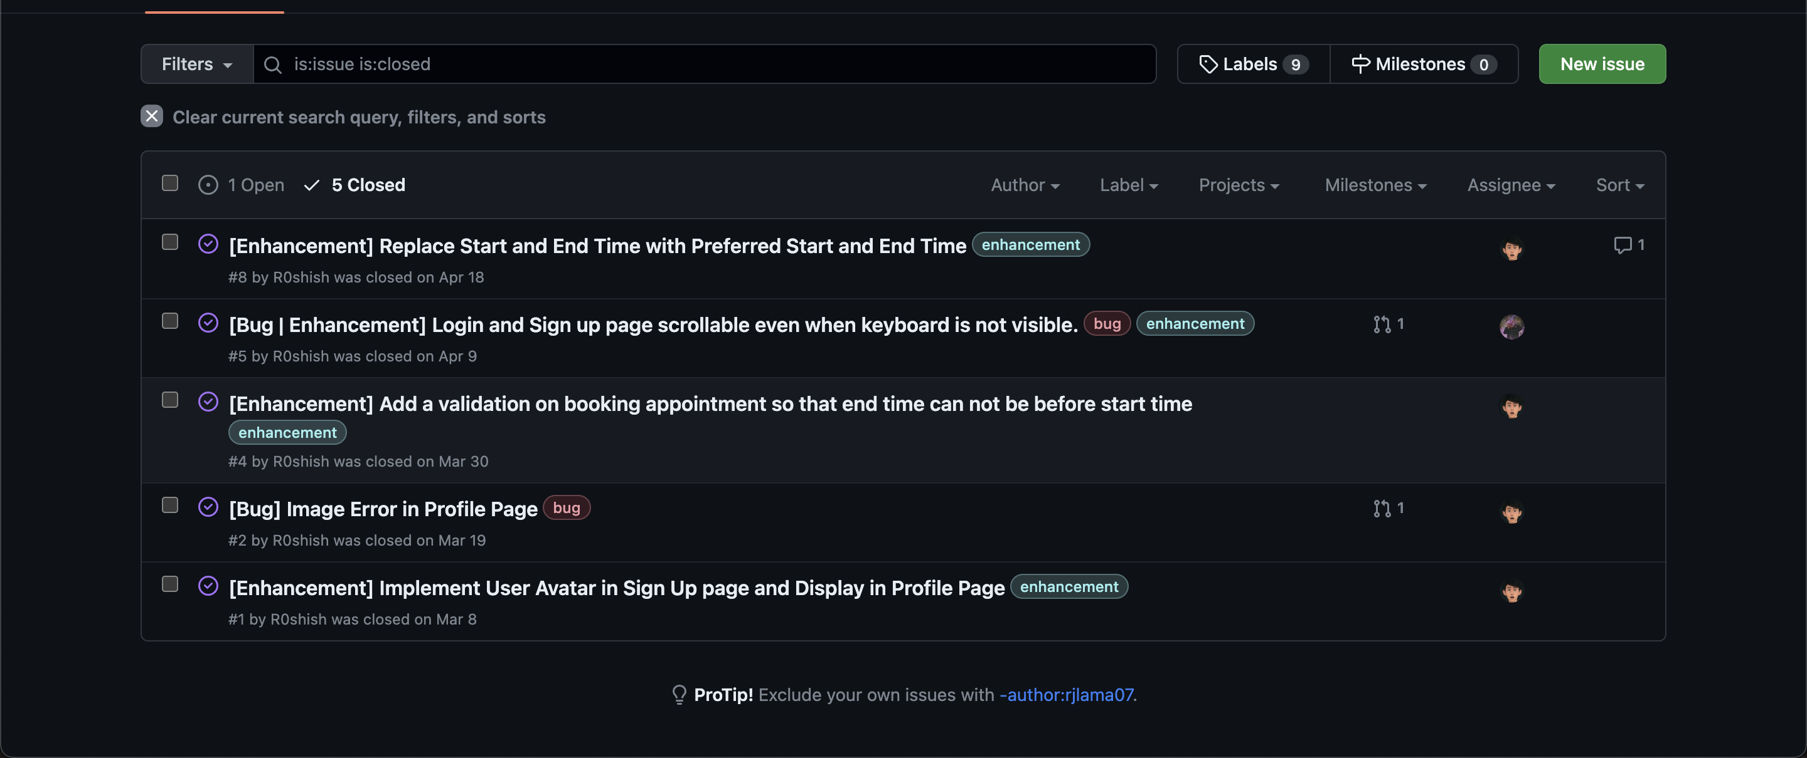

Figure 29 Issue tracking Screenshot

During the frontend development phase, I made sure to share my work on GitHub to facilitate collaboration with my team members. This allowed them to review and test the code I had written. While they were testing, they came across some minor issues, like the end time for booking appointments being set before the start time. I promptly took note of these issues and resolved them by implementing the necessary validations. It was important to me that the application worked flawlessly and provided a smooth user experience.

In addition to addressing these issues, our project manager provided some valuable suggestions for enhancing the overall functionality of the application. One of the suggestions was to add a user avatar feature to the Sign-Up page and display it on the profile page. I enthusiastically took on the task and successfully integrated these requested features into the project. By doing so, I not only met the project manager's expectations but also contributed to creating a more user-friendly experience.

Collaborating with my team members and addressing their feedback and suggestions has been instrumental in refining our project. It is through this collaborative effort that we have been able to create a high-quality application that meets the needs and expectations of our users.